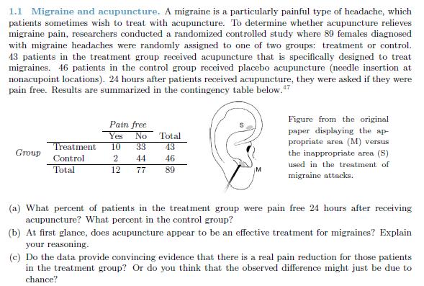

1. Pain Free Percentage:
   1. Treatment: 23%
   2. Control: 4%
2. Does Acupuncture Appear to be an effective Treatment?
   1. Yes, it appears to be working because there is a 19% difference between the treatment and control group when it comes to being pain free within 24 hours
3. Does the data provide convincing evidence that there is a real pain reduction for thoughts who went under acupuncture?
   1. Because of the large percentage difference in the two groups I am led to believe that acupuncture does work and made the observable difference above.

A.1

There are 202 black and 504 white adults in or near new York city between the ages of 20-94, who also have a BMI’s of 18-35 Kg/m^2

A.2

The study collected:

* Age (Discrete)
* Ethnicity (Categorical)
* Body Fat (Continuous)
* Weight (Continuous)
* Hight (Continuous)

A.3

To measure the accuracy of the BMI chart that is based on weight and height

B.1

129 University of California undergaduates at berkely who identify as low or high social-class

B.2

The Study Collected:

* Social-Class (Categorical)
* Candy Taken (Discrete)

B.3

A study of the relationships between socio-economic class and unethical behavior

1. The population of interest is all adults of black or white ethnicity, I believe that this study can be applied to the population if significant results are found.
2. All people within a higher or lower social-economic class, are in the population of interest. This study has nothing to do with unethical behavior because they were permitted to take some candy, and has nothing to do with class or crime.